EIT FOOD SALES BOOSTER PROGRAMME 2025
APPLICATION FOR GROWTH ADVISORS

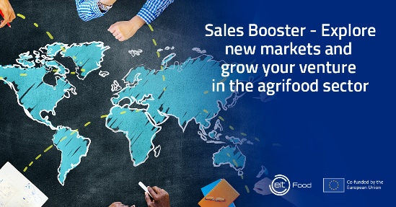

Please fill in the form and send it with your CV attached 15th June, 2025, 23:59 CEST, to salesbooster@eitfood.eu. with subject line: “Application + Your Name – Growth Advisors Sales Booster 2025 Programme”.

First name
Last name
Country of origin
Country of residence
E-mail
Telephone number with country code
LinkedIn profile, if applicable or website
PROFESSIONAL EXPERIENCE
Please provide justification of your experience related to business development, internationalization expertise, entrepreneurial, starting new business and serve new markets and/or investment background ( at least five years of proven professional experience)

KNOW-HOW
Please provide a short justification of knowledge in key areas such as value proposition and business model development, go-to-market strategies, financial management, customer acquisition.

MENTORING / COACHING
Please provide justification of your coaching/mentoring experience with startups and/or SMEs, other fast growing companies. Please state if you worked already in the agrifood sector in this regard?

NETWORK
Please provide examples of your experience related to a personal network of international contacts with businesses and markets / especially in agrifood sector

COUNTRIES
In which countries you can provide your expertise related to internationalization and access to network of agrifood companies / potential customers?

COST
Please provide the cost of your service per hour (net and with VAT)

*I am attaching CV
I acknowledge that I have read and understood the terms and conditions outlined in the General Data Protection Regulation (GDPR) information clause attached below, and I agree to abide by them in connection with my application. | Signature

GDPR information clause

- Providing of your personal data is voluntary, however in the event of failure to do so, you will not be able to take part in the Activity.
- Your data indicated in the Personal Data Form will be processed by the Controller pursuant to art. 6 sec. 1 (b) of the general regulation on the protection of personal data of April 27, 2016 ("GDPR") in connection with the implementation of the contract for participation in the Activity, what includes: provide full service, including solving technical and organizational problems, contacting you in connection with registration to the Activity, defense against possible claims, statistical purposes, as well as for the purpose of reporting the Activity under the European Union's Horizon Europe Framework Program, including documenting and disseminating the Activity, and therefore, for this purpose, the image of participants of the Activity may be processed and disseminated, where appropriate.
- Your personal data may be shared with:
- other participants of the Activity in order to conduct the Activity,
- other entities, persons or bodies that will process personal data as their independent controller - to the extent and on the terms set out in the law and the European Union's Horizon Europe Framework Program (e.g. project partners, EIT Food iVZW, entities authorized to conduct inspections and audits projects under the Horizon Europe Program - the European Institute of Innovation and Technology, the European Commission, the European Anti-Fraud Office (“OLAF”), the European Court of Auditors) as well as co-organizers of the Activity,
- persons authorized by the Controller, his employees and associates who must have access to data to perform their duties,
- processors to whom we entrust this task, e.g. those operating ICT systems, our advisors, related entities to the extent that they carry out data processing processes on our behalf (including EIT Food iVZW in the scope of providing us with resources, including ICT resources), entities providing photo/video services.
- The Controller of your personal data in connection with the registration of participation in the Activity is EIT Food CLC North-East sp. z o.o. with its registered office in Warsaw (00-534), ul. Mokotowska 64, Poland, entered into the Register of Entrepreneurs kept by the District Court for the capital city of Warsaw in Warsaw, 13th Commercial Division of the National Court Register under KRS number: 0000699422, NIP: 5213800253, REGON: 368613861, e-mail: ris@eitfood.eu.
- Your personal data will be stored for 5 years, due to the European Union's Horizon Europe Framework Program.
- The Controller does not intend to transfer your contact data to a third country or international organization, unless it is needed to use special tools that meet criteria of the GDPR.
- Your personal data is not subject of automated decision-making, including profiling.
- You have the right to lodge a complaint, when you consider that the processing of your personal data violates the provisions of the GDPR, to the President of the Office for Data Protection (or the supervisory authority dealing with the protection of personal data in another country, in particular in the Member State of your habitual residence, place of work or place committing the alleged infringement.
The list of competent authorities for the Member States can be found here: https://www.dlapiperdataprotection.com/index.html?t=authority&c=PL&c2=).

