7.4: Appendix 4: Roadmap
7.4.1: Roadmap protocol
- ROADMAPPING PRIORITY AREAS (Phase 3) In a multi-stakeholder workshop, 30 experts worked on (i) prioritisation of the roadmap drivers (ii) ideation of key opportunities; (iii) evaluation of the priority opportunities and (iv) deep diving into the top 7 priority opportunities in cross-functional breakout groups to develop a roadmap to a Fully Transparent, Resilient and Fair Food System, answering each of the identified priority action areas and knowledge gaps.

The objectives of this roadmapping exercise were to:
- Develop an understanding of the root cause of the problems around achieving a fully transparent, resilient, and fair food system
- Review the activities, operations and programmes occurring at country, European and global levels to deal with driving transparency, resilience, and fairness within food systems
- Evaluate, prioritise, and validate the opportunities and solutions for a fully transparent, resilient, and fair food system
- Construct a report to document the overarching roadmap and Impact Priority Areas for a fully transparent, resilient, and fair food system.
The overall research question to be answered was: What are the most powerful areas of intervention in the next 3-5 years that will allow for a fully transparent, resilient, and fair food system by 2050?

In Phase 3, we facilitated the co-creation of roadmap outlines in a multi-stakeholder workshop by refining the three identified priority areas and identifying the role(s) EIT Food could take. We synthesised the workshop results and elaborated on opportunities for EIT Food to lead change in these three areas and how EIT Food’s impact indicators can be met consistently in the next 3-5 years. We also searched for current and future stakeholders and collaborators including funding sources which might be available to fund development or scaling of solutions in these areas; and might be accessible by EIT Food and partner organisations working together as consortia.
3.4.1 Road mapping
The roadmap to A Fully Transparent, Resilient and Fair Food System sought to explore and validate initial desk-based research and data gathered and build a detailed understanding of specific priority opportunities for a transparent, resilient and fair food system. In order to achieve the project goals, the specific objectives of the road mapping workshop were to:
- Share perspectives on the vision towards a transparent, resilient and fair food system and the key value creation opportunities.
- Review and prioritise vision statements and the key trends and drivers.
- Ideate value creation opportunities and identify the priority value creation opportunities.
- Develop the impact pathways for the selected key value creation opportunities including identifying the enablers and resources required as well as any potential risks and discuss the potential role of EIT in such transitions.
- Review and feedback on the key value creation opportunities from both other missions.

Roadmaps provide a structured visualisation of information for specific strategic aspects. They are used to support strategic planning across a broad spectrum of applications. A common roadmap layout, or architecture, will contain two axes, as shown below in Figure 1. There is a horizontal, time-based axis; often encompassing the past, short-, medium- and long-term, as well as the vision. The vertical axis usually pertains to perspectives, or dimensions, relevant to the focal point of the roadmap; often represented as horizontal layers, forming a matrix across the time dimension.

To achieve the objectives described in Section ‘Background and Objectives’, the fast-start approach for strategic roadmapping (‘S-Plan’) developed by the Institute for Manufacturing (IfM) at the University of Cambridge was deployed. It is appropriate for a sector-level strategy, examining strategic challenges and exploring innovation opportunities. Generally, it is particularly suitable for understanding and addressing such issues at the ‘front-end’ of innovation, where decisions have considerable strategic implications.

Figure 2 shows the customised roadmap structure for the Mission 3 objectives. The vision and subsequent goals for the Transparent, Resilient and Fair Food System are on the righthand side of the roadmap showing the direction of change. The top layer ‘Why?’ captures the relevant trends, drivers and market needs that influence and drive the change. To address these drivers, the value creation opportunities are typically shown in the middle layer ‘What?’ of the roadmap. And finally, the bottom ‘How?’ layer contains capabilities, technologies, and enablers required to realise the opportunities.
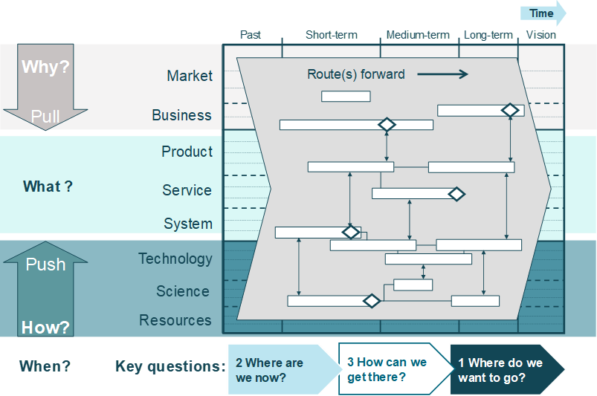
Figure 1: Generic roadmap structure
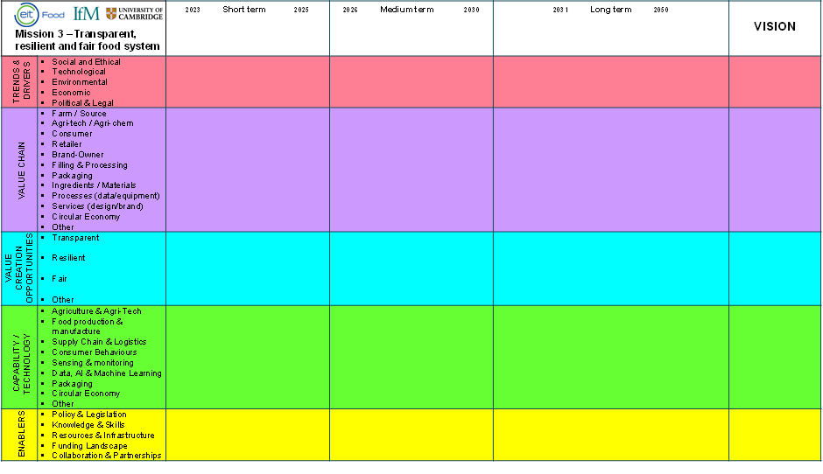
Figure 2: Roadmap landscape for mission 3
Ideally, to prioritise different value creation opportunities a full business plan would be created and those that would make the best contribution to the bottom line are selected. But often, and especially for value creation opportunities in their early stages, there may simply not be enough valid information to do this, and time and resources are limited. IfM’s portfolio prioritisation method provides a scoring and selection process for early-stage innovation ideas. It helps to evaluate those ideas using multiple impact and feasibility factors and not just financial criteria to reduce the uncertainty in decision-making. Both dimensions were defined as follows:
IMPACT: What is the contribution of the opportunities towards the vision for the transparent, resilient, and fair food system?
Impact factors:
- Overall impact of this opportunity space across whole food/drink sector
- Potential to scale - Deliverable improvement of roadmap vision by 2030
- Positive impact related to for example SDGs and other Missions
- Negative impact related to for example SDGs and other Missions
FEASIBILITY: How likely are these opportunities to happen from the technical, market and regulatory point of view?
Feasibility factors:
- Likelihood of Adoption across value chain
Farm => Brand => Retail => Consumer => Circular
- Technical probability of success: Feasibility of key technologies and capabilities required
- Relevance of role for EIT Food in enabling pathway to impact through innovation, education, entrepreneurship, and public engagement
- Regulatory, legal, safety and governance
The portfolio prioritisation was done based on an individual assessment of all opportunity ideas and a group review of the scoring results and the selection of the priority opportunities. Figure 3 shows schematically how the results are presented.
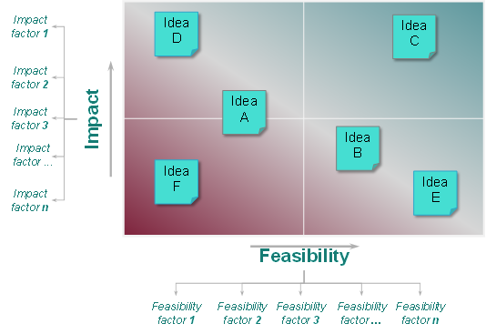
Figure 3: Prioritisation of the value creation opportunities
For mapping and evaluating the priority value creation opportunities, the topic roadmaps were utilised to describe the desired outcome including contribution to the Mission’s vision, main implementation milestones, capabilities, technologies and enablers required as well as likely barriers, risk aspects and potential knowledge gaps.
The overall design process of the roadmap for the Transparent, Resilient and Fair Food System is shown in Figure 4. The comprehensive data collection took place through:
- Review of >300 academic and industry publications,
- Conduction of 100 expert interviews,
- Collection of >350 survey responses,
- Identifying of ~100 case studies.
This data was used as an input to the road mapping workshops. Workshops are a core element of the road mapping process, bringing together key stakeholders to identify and explore exploitation routes for new/different ideas or research, support strategy formation, enable communication and formation of new networks, and build consensus for decision-making and action. The road mapping workshop was delivered via two half days in Paris, France with 35 participants from the international community consisting of academia, industry, and policy makers (see Annex for workshop agenda and the participants list). Mission 3 workshop took place in parallel to the workshops of both other missions.
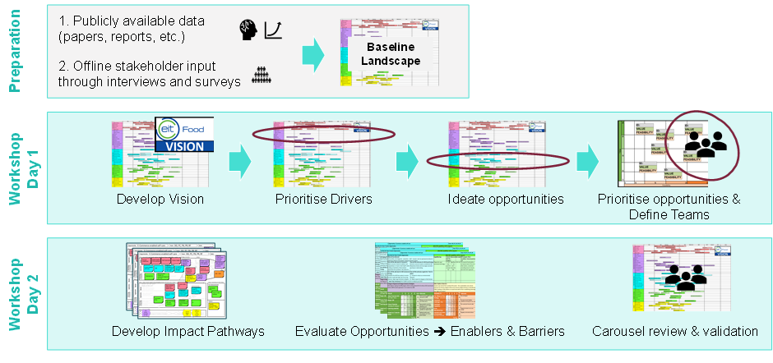
Figure 4: Overview of the road mapping process
The final stage of the process was a review of the opportunities across all missions, where the delegates were able to comment, add information as well as indicate any cross-linkages between the missions.

The final exercise on the EIT Food Mission roadmap to A Fully Transparent, Resilient and Fair Food System was to critically analyse and synthesise all the information collected through the literature reviews, questionnaires, surveys and expert opinions in order to provide key recommendations on how EIT Food can make a distinctive and significant impact on A Fully Transparent, Resilient and Fair Food System and how EIT Food’s impact indicators can be consistently met in the next 3-5 years. The recommendations took into consideration the objectives of EIT Food as described in the EIT Food Strategy 2021-2027 and the EIT Food Business Plan 2030-2025, with a focus on how EIT Food can meet its impact indicators consistently in the next 3-5 years. Recommendations were explored in the with consideration of EIT Food’s four: pillars Education, Innovation, Business Creation and Public Engagement. However, additional enablers were EIT Food can play a critical role also emerged. notably partnerships and lobbying government and policy. A number of cross-cutting priority impact areas and topics with the other EIT Food Missions: Healthier Lives Through Food and A Net Zero Food System also emerged. However, only general insights resulting from the co-design process were captured and more work is required for concrete actions and recommendations.
To conclude the road mapping exercise, a search was completed on the current and future stakeholders and collaborators including funding sources which might be available to fund development or scaling of solutions in these areas; and might be accessible by EIT Food and partner organisations working together as consortia.

Figure 22 captures the details of the prioritised roadmap that emerged from the workshops, and the following Figures provide the full detail of the topics identified and explored through the workshops. Priority capabilities and enablers are identified as focal points for future strategy development of EIT Food.
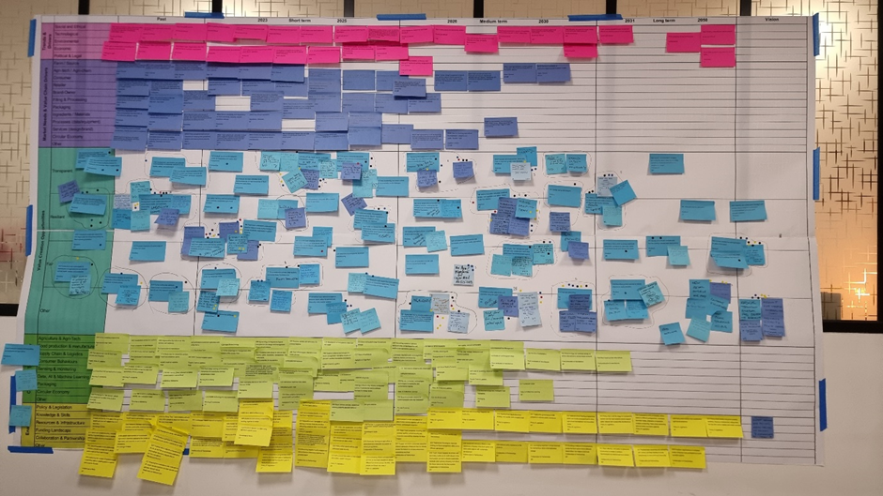
Figure 5: Photograph of the paper-based road mapping landscape wall chart (Developed and validated with the delegates during the workshops)
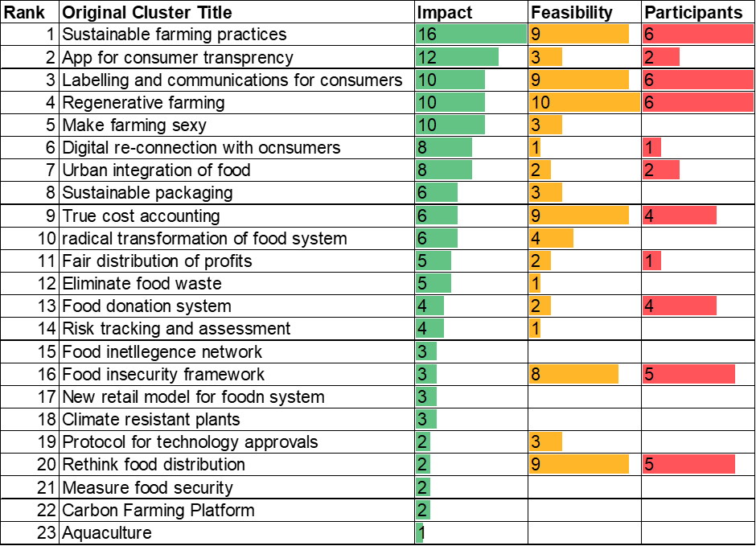
Figure 6: Short list of value creation opportunities

7.4.1: Topics developed from desk research, surveys and interviews.

7.4.1a: Trends & drivers
# | TREND/DRIVER | Sub-Layer | Timescale
TD01 | Climate change, weather unpredictability and extreme weather events threatens food production, safety and can directly exacerbate food insecurity | Environmental | S/M
TD02 | Growing populations and increasingly affluent are adding pressure to food systems | Social and Ethical | L
TD03 | Migration demands for longer supply chains and adds further pressure | Social and Ethical | M/L
TD04 | Growing & complex global food supply chains increases food fraud vulnerability | Social and Ethical | M/L
TD05 | Lack of harmonisation surrounding food fraud regulation & enforcement | Political & Legal | Past
TD06 | Rapid urbanisation, growth of megacities, and population growth in urban settlements | Social and Ethical | M/L
TD07 | Scarcity of natural resources/land degradation | Environmental | M/L
TD08 | War & conflict: Social unrest and political conflict can place pressure on the resilience of the food supply chain, destroy infrastructure, equipment, and machinery, restrict access to agricultural labour, and disrupt the supply of agricultural commodities | Social and Ethical | S/M
TD09 | Increase in foodborne illness/food contamination | Environmental | S/M
TD10 | Pandemics, epidemics, and crises situations | Social and Ethical | S/M
TD11 | Refugee crisis, Human trafficking, and Exploitation | Social and Ethical | S/M
TD12 | Unfair justice and democracy system | Social and Ethical | S/M
TD13 | Growing competition and cost for energy | Economic | S/M
TD14 | Use of crops for energy or non-food materials (e.g., fibre, for textile) | Technological | M
TD15 | Unfair access to resources across the globe | Economic | L
TD16 | Social Movements | Social and Ethical | S
TD17 | World Trade Organisation rules and agreements do not foster sustainability | Economic | S
TD18 | Misuse of digital technologies for surveillance of citizens has led to distrust within consumers | Technological | S
TD19 | Capitalism driven by profit and policies which favour capitalism | Economic | S
TD20 | Work stress and long working hours | Social and Ethical | S
TD21 | Flexible working arrangements post Covid-19 | Social and Ethical | S
TD22 | Rampant inflation and increasing cost expenditures | Economic | S
TD23 | Poverty, inequality, and social security | Social and Ethical | L
TD24 | Information from social media and Influencers | Social and Ethical | Past
TD25 | Aging population which come from a time of war and appreciate what they have and can afford as opposed to demanding sustainability factors | Social and Ethical | Past
TD26 | Political instability, continuous rapid change of regulations globally and geopolitical shift of power | Political & Legal | S/M
TD27 | Labour and skills availability | Social and Ethical | S/M
TD28 | Increasing social innovations | Social and Ethical | S
TD29 | Movement towards locally sourced foods | Economic | S
TD30 | Availability of new technologies | Technological | L

7.4.1b: Market needs
ID | CLUSTERS – LANDSCAPE Market needs | Sublayer | Time
MN01 | Sustainable and resource efficient farming practices | Farm / Source | ST
MN02 | Alternative proteins to alleviate resource intensive agriculture | Agri-tech / Agri-chem | ST
MN03 | Pressure from NGO's and Advocacy campaigns for sustainable fisheries | Other | ST
MN04 | Flaws in EU catch certificate scheme (CCS) | Other | ST
MN05 | Exploitation of humans and animals and unethical issues in animal production | Farm / Source | ST
MN06 | Climate change is expected to reduce crop yields in regions that are required to produce more in the future, and to increase variability in productivity in other regions | Farm / Source | MT
MN07 | Increased prevalence and risk of mycotoxins in animal feed which reduce animal performance | Farm / Source | ST
MN08 | Antimicrobial resistance | Farm / Source | ST
MN09 | Plant and animal biosecurity: Expansion and spread of pests and diseases into new regions, introducing new unknowns to local farm management | Farm / Source | MT
MN10 | Diversified farming systems have received minimal public and private investments. Decline in social-ecological resilience of farms and of rural communities. | Farm / Source | Past - ST
MN11 | Lack of knowledge and time for farmers to implement innovations and best practices for a more resilient system | Farm / Source | Past
MN12 | Food Specialization: A small number of plant and animal species supply 90% of the world’s calories | Farm / Source | ST-MT
MN13 | Intensive, industrialised, and unsustainable farming practices to feed the global population and for increased profits | Farm / Source | Past
MN14 | Addressing Pollution (air, soil, and water) is crucial for the health of the whole system | Other | ST
MN15 | Misinformation and misuse of metrics have demonised the livestock industry when highly industrialised artificial substitutes are being promoted | Processes | ST
MN16 | Market liberalization and price volatility drive changes in all farming systems. Market pressures bringing down prices at production point. | Farm / Source | Past - ST
MN17 | Decline in water availability | Farm / Source | ST
MN18 | Decline in availability of productive arable land and nutrients in soils | Farm / Source | ST-LT
MN19 | Social, ecological, and economic components of food systems remain unsustainable | Other | ST
MN20 | Current food system promotes privatization, exports, and limited transparency | Other | Past
MN21 | Food systems are vulnerable to fraud which negatively impacts brand reputation. Proactive policy addressing and bespoke plans for the mitigation of food fraud | Other | ST
MN22 | Need in traceability and transparency for food authenticity, including relevant analytical methods | Processes | ST
MN23 | Poor digitalisation and interconnectedness led to lack of information for decision making | Processes | Past
MN24 | Supply chains are complex and governance there is insufficient accurate controls from farm to fork, from local to global marketplaces. | Other | ST
MN25 | Use of local ingredients | Ingredients / Materials | ST
MN26 | Inequity and power imbalance within the food system with dominant actors having power over the food system, where large corporations remain the main stakeholders of beneficiaries of policies and funding | Brand-Owner | Past
MN27 | Secrecy and in-transparency is a pillar in the strategy of commercial organisations and powerful actors, driven by economic greed with profitability over accountability at the expense of consumers and ecosystem health | Brand-Owner | ST
MN28 | All stakeholders in the food system want to earn money. Money ranks first and actors will make things 'foggy' to make more money. | Other | ST-LT
MN29 | Tools to provide reliable information to consumers for a competitive edge | Brand-Owner | ST
MN30 | Fear transparency could be expensive and a competitive disadvantage as even with the best of intentions it can be difficult to source raw materials from supply chains with integrity. | Other | ST
MN31 | Excessive pressure on food companies for returns and profits from investors and financial markets | Brand-Owner | ST
MN32 | There is no clarity around food and food system associated resources | Brand-Owner | ST
MN33 | Food industry is driven to outcompete competitors for private gain, thus brining cheap, unsustainable, and less healthy products to market | Brand-Owner | ST
MN34 | Highly processed foods in national school’s lunch programmes | Services | Past
MN35 | Consumers are disconnected from the food system due to issues within education and children not being told about where their food comes from. Low awareness and knowledge of unsustainable ingredients and ecolabelling | Consumer | Past
MN36 | Consumers are driven by economics and saving money with a low interest in the more for transparent, resilient, and fair food system, spending money on food and seeking out cheaper brands | Consumer | Past
MN37 | Consumer distrust in the food industry and food labelling as well as regulatory bodies responsible for food safety | Consumer | ST
MN38 | People in western countries are not willing to change their diets or lifestyles with high meat consumption | Consumer | ST
MN39 | Cultured meat to feed the global poor is unethical. Fear cultured meat will be 'slipped' into the diets of the poor | Consumer | ST
MN40 | Clear and accurate food labelling (sustainability, genetically modified, information on food allergies) verified by a trusted and independent organisation as opposed to overkill of information being shared | Brand-Owner | ST
MN41 | Changes in consumer and social behaviour: recycling leftovers, healthy, nutritious food choices, demand for food safety, growing own food | Consumer | ST-MT
MN42 | Substantial changes in food procurement by consumers. Tech savvy consumers. | Consumer | ST
MN43 | Less attention has been paid to the resiliency characteristics of the final link in the food system – individual households | Consumer | ST
MN44 | Food assistance programmes address immediate issues but need to address underlying issue of poverty. An inefficient/ineffective charitable food sector. | Other | Past-ST
MN45 | Need to be a focus on food system transformation to address ultimate reasons for food poverty | Other | ST
MN46 | Food pricing does not embed externalities e.g., ecosystem services, nature and soil | Other | Past
MN47 | Interventions across the food system for resiliency | Other | ST
MN48 | Policy and government are not interested in changing their global food systems and reducing food insecurity | Other | Past-ST
MN49 | Need for fostering regionalized food distribution networks and waste reduction | Food System / Industry | ST-MT

7.4.1c: Opportunities
Cluster (in workshop) | ID | Opportunity | Sub-Layer | Time | Timescale | Links to key trends, drivers, market needs | Contributed by (initials)
Digital Connection | O01 | Digitalising the supply chain to provide more insight, increase efficiencies and chain-of-custody information | Transparent | MT | 2025-2030
Digital Connection | New | Increase the digital connection of food to the consumer (technological) | Transparent | MT | 2023-2035 | 8  H | HG
Digital Connection | New | Re-connect consumer: Food in school curriculum from 5 years old | Transparent | ST | 2023-2025 | 1,2  H | SD
 | O02 | Secure, connected, and intelligent technology for secure data management, authenticity of records and advanced analytics for insight | Transparent | MT | 2025-2030
 | O03 | Development of regional risk-based networks of food and feed producers to measure and evaluate risks in supply chains | Transparent | ST | 2023-2025
 | O04 | Development of a European Food intelligence and Information network working together to sample, measure and mitigate food fraud | Transparent | Past | Past
 | O05 | A robust, secure, and tamperproof system for traceability and supply chain management | Transparent | ST | 2023-2025
 | O06 | Development, optimization, and practical implementation of analytical methods for food quality, safety and authenticity | Transparent | ST | 2023-2025
 | O07 | Robust, low cost, and easy to use handheld devices for rapid screening for food safety and authenticity | Transparent | ST | 2023-2025
 | O08 | Scientifically robust evaluation of food and food system associated resources for different commodities, production systems and technologies | Transparent | ST | 2023-2025
Apps for conscious consumer decisions | O09 | Scientifically robust, reliable, and trusted food labelling systems | Transparent | ST | 2023-2025
Apps for conscious consumer decisions | New | Consumer individualised app for accessing food information | Transparent |  |  | 1  Y | UG
Apps for conscious consumer decisions | New | Consumer feedback on impact of food choices | Transparent |  |  | 1  Y | UG
Apps for conscious consumer decisions | New | App that helps consumers with info in food supermarket | Transparent | MT |  | 5, 8  A,C,E,F,H | MT
Apps for conscious consumer decisions | New | App/platform for informed decisions | Transparent
Apps for conscious consumer decisions | New | A new app for consumer in 2024. | Transparent |  |  | I, J
Apps for conscious consumer decisions | New | Personalised consumer app for accessing food information and giving feedback from a reliable, helpful source. | Transparent
Apps for conscious consumer decisions | New | Help (young) consumers to make sustainable choices. | Transparent |  |  | 3,4,5  O,E
Brand Impact | New | Database on environmental impact of food at brand level | Transparent |  |  | 1  H | UG
Brand Impact | New | Brand impact on environment | Transparent
Accurate food insecurity  measurement and indicators | O11 | Precise and focused definition, measurement and assessment of food security and food insecurity indicators | Fair | ST | 2023-2025
Accurate food insecurity  measurement and indicators | New | Priority opportunity to find measurements  and indicators to assess food insecurity | Fair | ST | 2023-2025 | 2 | FF
Affordable food system | O12 | Framework that tackles food insecurity driven by rising food prices | Fair | ST | 2023-2025
Affordable food system | New | Make the food prices fixed. Lower the price of local and quality food. Make it more affordable | Fair | MT | 2026-2030 | 7  D | FF
Affordable food system | New | Use of circular food production systems that maximised efficiency while reducing water usage such as Aquaponics or 3-tropatic systems | Fair |  |  | 8  B
Shift towards sustainable diet | O13 | Establish food reference budgets to promote health eating and prevent food insecurity in low-income contexts | Fair | ST | 2023-2025
Shift towards sustainable diet | New | Different definition of a 'proper meal' - (rule of meat) | Fair
Shift towards sustainable diet | New | New plate model - moving away from "meat & 2 veg" | Fair
Shift towards sustainable diet | New | Integrate food welfare into food policies - food not as common food and not as a commodity. | Fair
Restructure Food Assistance Programmes | O14 | Restructure and expand food and nutrition assistance measures programmes, increase ease of access and reduce stigma | Fair | ST | 2023-2025
Restructure Food Assistance Programmes | New | Redefining the assistance programmes in order to father access to (x), food, social inclusion and reduce social stigma | Fair | ST |  | 2  D | FF
Food donation - Vulnerable People | O15 | Interventions to connect older adults to community-based food resources | Fair | ST | 2023-2025
Food donation - Vulnerable People | New | Facilitation & fostering of food donation through stronger legislative framework (EU & National level) | Fair |  |  | 2,3,4,5 | AF
Food donation - Vulnerable People | New | Opportunity- Recognise & exploit the potential of food donation to foster its social environmental & economic impact | Fair |  |  | 2,3,4,5 | AF
Food donation - Vulnerable People | New | Poverty, Inequality, and food security. Policy drivers  Short term opportunity - publicization of food welfare.  Med-term opportunity - food democracy as policy objective  Long-term opportunity - systemic and integrated food welfare within public policies | Fair |  |  | 2 | VA
Accessible food for all Initiatives  All stakeholder involvement  in sustainable, healthy food distribution | O16 | Participatory initiatives to rethink the distribution of food resources and the limitations of social policies. | Fair | ST | 2023-2025
 | New | Alternative food networks consortium creation. Access to high quality food | Fair | ST-MT | 2023-2030 | D, J, 7 | RB
Intersection between cities and agriculture | O17 | A planning structure which links urban and rural areas to address food insecurity | Fair | LT | 2030-2050
Intersection between cities and agriculture | New | Local educational programmes that re-create, link urban citizen and farmers | Fair |  |  | H | DJ
Intersection between cities and agriculture | New | Distributed food system re-localised in bioregions as the unit of change | Fair |  |  |  | DJ
Fair Trade | O18 | Initiatives which ensure fair profit distribution along the supply chain | Fair | MT | 2025-2030
Fair Trade | New | Make fair trade the new normal | Fair | MT/LT | 2026-2050 | 2,4,7  D, H, I, J | LO
Fair Trade | New | Distribute profits fairly along supply chain | Fair | ST/MT | 2023
Fair Trade | New | Fixed food price. Fair/accountability, political outputs. | Fair
Fair Trade | New | Fair trade factories & fair food prices. | Fair |  |  | D,E
Food Cost - Accessible & Healthy | O19 | True cost accounting | Fair | MT | 2030-2050
Food Cost - Accessible & Healthy | New | Implement true cost accounting to push out of business big, processed food
Food Cost - Accessible & Healthy | New | Implement food social security scheme; free raw food for all |  |  |  | J | DJ
Food Cost - Accessible & Healthy | New | Drastically tax processed food (including 3D food) | Fair |  |  |  | DJ
Food activism  Mapping the relationship | New | New revival models for food | Fair
Food activism  Mapping the relationship | New | B2B - Trust Tracker | Fair
Food activism  Mapping the relationship | New | Contract Structures | Fair
Food activism  Mapping the relationship | New | Make power dynamics visible | Fair
Food activism  Mapping the relationship | New | Account food negative externalities | Fair | LT
Food activism  Mapping the relationship | New | Use current food system structures to better distribute food produced.
Food activism  Mapping the relationship | New | Support cooperatives & food producers - affordable supermarkets
Food System Transformation | New | Radically simplify food chains (from global to proximity) | Fair | LT
Food System Transformation | New | Account food negative externalities
Food System Transformation | New | Radically transform global food system | Fair
Food System Transformation | New | Make food & agriculture a common? | Fair |  |  | 7 | DJ
Resource Stewardship | O20 | Local, global, and cross-scale food resiliency analysis, measurement of indicators and development of a food resiliency framework | Resilient | MT | 2030-2050
Resource Stewardship | New | Resource stewardship - water& energy efficiency alternative sources of water, energy | Resilient |  |  | 1,3  B,A
Regenerative Agriculture | O21 | Sustainable food production practices and diversified farms for plant and faunal diversity, soil fertility, improved use of land, conserving natural resources, reducing GHG emissions and animal welfare. | Resilient | ST | 2025-2030
Regenerative Agriculture | New | Make regenerative agriculture the new normal mid-long term | Resilient | MT/LT | 2026-2050 | 1,3,8  A,B,C,E,I | LB
Regenerative Agriculture | New | Global support companies on regenerative agriculture (supply & demand)
Risk Management | O22 | Sustainable control of emerging and increased prevalence of pests, natural toxins, contaminants and disease in primary production, storage, and transport | Resilient | ST | 2023-2025
Risk Management | New | Develop novel ways to identify /manage emerging and possible risks | Resilient |  |  | 1  B,G
Risk Management | O23 | Tackle and reduce the challenges around antimicrobial resistance, improving veterinary diagnosis whilst ensuring productive, safe, and healthy food production | Resilient | ST | 2025-2030
Farm - level Sustainability  & Farmer Support | O24 | Farm-level sustainability assessments and baseline measurements to allow farmers to engage as globally responsible biosphere stewards. | Resilient | ST | 2023-2025
Farm - level Sustainability  & Farmer Support | New | Supporting farmers in building localised solid health knowledge | Resilient
Farm - level Sustainability  & Farmer Support | New | Mitigation solutions (med on bacteria?) microbiology | Resilient |  |  | 3
 | O25 | Carbon farming platforms and schemes which promotes sustainable agricultural practices | Resilient | ST | 2023-2025
 | O26 | Prediction models and forecasting technologies for agriculture | Resilient | ST | 2023-2025
Agricultural Technologies | O27 | Implement smart technologies (& digitalisation) in agriculture for soil, plant and animal health, welfare and productivity | Resilient | ST | 2025-2030
Agricultural Technologies | New | Clear pipeline or protocols for approval of new schemes or technologies | Resilient | ST/MT | 2023 - 2030 | 8  I | AR
 | O28 | Innovations to help with efficient use of labour in agriculture | Resilient | ST | 2023-2025
Climate Resistant Food | O29 | Production of climate resilient plants and crops for improved growth under changing conditions | Resilient | MT | 2025-2030
Climate Resistant Food | New | Diversification of farming, climate resistance crops | Resilient | MT-LT | 2026 -2050 | 1  B,F | SF
Climate Resistant Food | New | Support perennial crop agriculture (trees, bushes, etc) that impact micro/local climate | Resilient |  |  | B | DJ
Climate Resistant Food | New | Reduce CO2 emissions, produce more resilient food items. | Resilient
 | O30 | Innovations to improve animal feed conversion, performance, health, and welfare | Resilient | MT | 2025-2030
 | O31 | Participatory initiatives with farmers to help them adopt sustainable farming practices and innovations, build long term business strategies, and build resilience | Resilient | ST | 2023-2025
 | O32 | A strong and sustainable aquaculture and algae sector for animal feed and food to feed a growing population | Resilient | ST | 2023-2025
 | O33 | Promote production of a wide range of nutrient rich foods | Resilient | ST | 2023-2025
 | O34 | Technology to improve the nutritional quality of food | Other | ST
Less meat/ Sustainable meat options | O35 | Innovation and initiatives which sustain the positive role of meat in the human diet and contribution to food security while easing the impact on the environment. | Resilient | ST | 2023-2025
Less meat/ Sustainable meat options | New | Less meat consumption. Habits shift towards more plant-based diets
Alternative protein | O36 | Diversifying protein sources to reduce reliance on meat production | Resilient | ST | 2023-2025
Alternative protein | New | Circular economy & alternative proteins | Resilient | MT | 2026-2030 | 3,5  F,E | AR
Alternative protein | New | Switch to a more plant-based eating pattern to help the climate and nature | Resilient | LT | 2030-2050 | J,F | JA
 | O37 | Innovative technologies for advanced manufacturing | Resilient | ST | 2025-2030
 | O38 | Control of temperature and the cold chain in transport and storage | Resilient | ST | 2025-2030
Increase in sustainable packaging | O39 | Packaging and alternative packaging materials which lower environmental footprint, address any migration of contaminants to food and reduce packaging and food waste | Resilient | ST | 2023-2025
Increase in sustainable packaging | New | EPR (Extended Producer Responsibility) to other areas in supply chain | Transparent | ST | 2023-2025
Food Waste Reduction | O40 | Initiatives and innovations to reduce carbon and plastic waste and create a resource efficient and safe circular economy.
Food Waste Reduction | New | Stop any food waste | Resilient | ST | 2023 - 2025 | 4,3,1 ,5  A,E | LB
Food Waste Reduction | New | Mechanisms aimed at reduction of waste. Suggestion; Sanctions. | Resilient
Food Waste Reduction | New | Utilise widely all plant/animal species. Considering impact (Ecosystem, sustainability, health & environment) | Resilient |  |  | 1  C | II
 | O41 | Alternative fuel for agriculture | Resilient | LT | 2030-2050
 | O42 | Energy saving technologies | Resilient | MT | 2025-2030
Use of GM | New | Use of GM products (2030) - affordability & availability | Resilient | ST/MT | 2023-2030 | 3 | HG
Use of GM | New | Generalise low energy/ low input agriculture practices. (Agroecology)  Today: 10 calories of oil for 1 calorie of food produced. |  |  |  | 6 | DJ
Intersection between cities and agriculture | O43 | Connect architecture and agriculture for cities of the future | Resilient | LT | 2030-2050
Intersection between cities and agriculture | New | Food as an entitlement, right based approach to food access | Fair
Intersection between cities and agriculture | New | Peri-urban agriculture simulation, control safe production. | Fair |  | 2023-2030 | I, 3 | RB
Supply Chain Optimisation | O44 | Supply chain management and innovations in transport and distribution which lower the environmental footprint | Resilient | MT | 2025-2030
Supply Chain Optimisation | New | To improve people's lives (map supply chain to show they are free from forced labour) | Resilient | MT | 2025-2030 | 2,4,7  C,D,I | ES
Supply Chain Optimisation | New | To improve efficiency in (?)/purchasing/supply chain management to reduce food waste etc. | Resilient |  |  | 3,6,8  D,E,F,I,J | ES
Supply Chain Optimisation | New | Predictive analytic tools to balance demand/supply & avoid waste | Resilient |  |  | B,A | II
Empowering Consumers | O45 | Building more self-sufficient consumers to fight food insecurity | Resilient | MT | 2025-2030
Empowering Consumers | New | Increase the perceived value of our food  - Education  - Dialogue with stakeholders  - Campaign (advocacy) | Resilient |  |  | 1  B,J,E
 | O46 | Interventions which re-engage and build consumers confidence to cook food, utilise novel food products and reduce food waste | Resilient | MT | 2025-2030
Educate youth for conscious  consumer decisions | O47 | Interventions which educate young people on how to choose sustainable products when grocery shopping | Resilient | ST | 2023-2025
Educate youth for conscious  consumer decisions | New | Teach nutritional intrinsic value of food to young (Sustainability) | Resilient |  |  | 2,5  J,H | II
Educate youth for conscious  consumer decisions | New | Help youth to make sustainable choices | Resilient |  |  | 3,4,5  O,E
Educate youth for conscious  consumer decisions | New | Incentive for parents who care about sustainable, healthy, and fresh food for their children. Printed as vouchers | Resilient |  | 2026-2030 | 2 | FH
Educate youth for conscious  consumer decisions | New | Teaching all teenagers in farming skills at secondary school level | Resilient |  |  | 4  H
Accessible information to  help drive consumer behaviour change | O48 | Enhance knowledge and critical thinking of consumers to seek reliable information and move towards healthy and sustainable consumption | Resilient | ST | 2023-2025
 | New | EU-wide eco-label for consumers | Resilient |  |  |  | UG
 | New | Environmental food labelling data standards | Resilient | ST | 2023-2025 | 3,7  G,I,E,A,F,H,J | AMZ
 | New | Raising people's awareness & school programmes | Resilient |  | 2023-2025 |  | RB
 | New | Educating people (farmers, consumers, governments, corporations, children, students. Etc) to sustainable food solutions and practices | Resilient | ST/MT/LT | 2023 - 2050
 | New | Increase design involvement in consumer information so it works for low tech users, not just the digital natives. |  |  |  | 8  I,J
Make Farming Sexy | O49 | Interventions within schools to build food literacy, food awareness and attract citizens to the food industry | Resilient | ST | 2023-2025
Make Farming Sexy | New | Opportunity - make the job of the farmer sexy
Make Farming Sexy | New | 3x more farmers in EU by 2030
Make Farming Sexy | New | Generalise agroecology/ agroforestry with subsidies to farmers.
Make Farming Sexy | New | Empowering farmers and local communities through regenerative practices and business models | Resilient | MT | 2026-2030 | 1,7  A, H, J, D, E, C | WCS
Make Farming Sexy | New | Make farming a desirable job  - guarantee good income.  - Make it social & rewarding  - Create millions of jobs  - Reinforce rural communities | Resilient
 | O50 | Collective and collaborative foresight and scenario-based insights to understand outputs of different activities within complex systems | Resilient | LT | 2030-2050
Food System Policies | O51 | Review and critically evaluate laws that are creating unsustainable food systems | Resilient | MT | 2025-2030
Food System Policies | New | Faster and more forceful legislation for health of people & planet | Resilient |  |  |  | SK
Local Initiatives | New | Introduce measures to support local procedures | Resilient |  |  | 4  E
Local Initiatives | New | Upskill, provide tech & enable communities to produce own food. | Resilient
Farming Pollution Reduction | New | Reduce pollution generated by food (pesticides, microplastics from packaging) | Resilient
Farming Pollution Reduction | New | Liberalise/free the use of non-proprietary seeds. (Ban EU seed list) | Resilient |  |  | C | DJ

7.4.1d: Capabilities
ID | Capabilities/Technologies | Sub layer | Timeframe
C01 | Food safety tracking and modelling frameworks for quantifying chemical contaminants in food | Sensing & monitoring | 2023-2025
C02 | Risk assessment tools for food fraud prevent and mitigation | Supply Chain & Logistics | Past
C03 | Mass spectrometry (MS) usually coupled to liquid (LC) or gas chromatography (GC), capillary electrophoresis (CE), infrared spectroscopy (IR) and nuclear magnetic resonance (NMR) spectroscopy for food authentication | Sensing & monitoring | 2023-2025
C04 | BIAcore technology for food traceability  and other applications | Sensing & monitoring | 2023-2025
C05 | Radio Frequency for cheese production | Sensing & monitoring | 2023-2025
C06 | Microscopy (Near infrared) to detect contaminants in animal feed | Sensing & monitoring | 2023-2025
C07 | Extraction of DNA and nucleic acid sequences for determining the origin and authenticity of food products | Sensing & monitoring | 2023-2025
C08 | Biosensors | Sensing & monitoring | 2023-2025
C09 | Fingerprinting techniques for food safety and integrity | Sensing & monitoring | 2023-2025
C10 | REIMS technology for food authenticity | Sensing & monitoring | 2023-2025
C11 | RFID smart tags for management of the logistics of the supply chain | Supply Chain & Logistics | 2023-2025
C12 | High resolution melting analysis to identify raw materials in food | Sensing & monitoring | 2023-2025
C13 | Handheld NIR for food authentication | Sensing & monitoring | 2023-2025
C14 | Blockchain for traceability, product recall and credence claims | Supply Chain & Logistics | Past
C15 | QR Codes and food labelling | Food production & manufacture | Past
C16 | Big Data, Artificial Intelligence and Machine Learning | Supply Chain & Logistics | 2025-2030
C17 | Computer Vision | Data, AI & Machine Learning | 2025-2030
C18 | Internet of Things | Data, AI & Machine Learning | 2025-2030
C19 | Manufacturing 4.0 | Food production & manufacture | 2025-2030
C20 | Virtual Reality | Consumer Behaviours | 2025-2030
C21 | European open cloud for data on food quality, safety, traceability, transparency, and authenticity | Food production & manufacture | 2023-2025
C22 | Controlled environment agriculture and vertical farms | Agriculture & Agri-Tech | 2023-2025
C23 | Robotics, drones, and automation for precision farming | Agriculture & Agri-Tech | 2023-2025
C24 | Microbiome technologies for crops and soil health | Agriculture & Agri-Tech | 2023-2025
C25 | Gene editing technology for plant and animals | Agriculture & Agri-Tech | 2025-2030
C26 | Animal breeding programmes | Agriculture & Agri-Tech | 2023-2025
C27 | Aquaculture production systems | Food production & manufacture | 2023-2025
C28 | Algae Biotechnology | Food production & manufacture | 2023-2025
C29 | Agroecology to integrate ecological principles into the design and management of agricultural systems. | Food production & manufacture | 2025-2030
C30 | Regenerative Agriculture can help achieve real resilience | Food production & manufacture | 2023-2025
C31 | DSS: Decision support system | Supply Chain & Logistics | Past
C32 | Road infrastructure, internet access, mobile phones | Supply Chain & Logistics | 2023-2025
C33 | Nanotechnology and Intelligent Food Packaging | Packaging | 2025-2030
C34 | Finding use for "fifth quarter", animal biproducts such as offal, hides & skins, blood etc. | Circular Economy | 2023-2025
C35 | Predictive analytic technologies for stock management, managing supply and demand, weather forecasting and beyond | Supply Chain & Logistics | 2023-2025
C36 | Forecasting models for optimum plant production for feed based on soil, weather (new agronomic systems) | Agriculture & Agri-Tech | 2025-2030
C37 | Water infrastructure | Agriculture & Agri-Tech | 2023-2025
C38 | Repair degraded soils via re-vegetation initiatives, reduce soil erosion by maintaining year-round plant cover | Agriculture & Agri-Tech | 2023-2025
C39 | Effective marketing strategies | Consumer Behaviours | 2023-2025
C40 | Communication strategies | Consumer Behaviours | 2023-2025
C41 | Biotechnology and synthetic biology to deliver alternatives to animal-based products | Food production & manufacture | 2025-2030
C42 | Precision Fermentation | Food production & manufacture | 2025-2030
C43 | Cultured and lab grown meat | Food production & manufacture | 2025-2030
C44 | Plant based protein alternatives | Food production & manufacture | 2023-2025
C45 | Prolonging shelf life of food without the use of Co2 | Packaging | 2023-2025
C46 | Apps for farmer monitoring | Agriculture & Agri-Tech | 2023-2025
C47 | New ways of shopping and virtual reality | Consumer Behaviours | 2023-2025
C48 | Digital Marketplaces | Consumer Behaviours | 2023-2025
C49 | Tools for predicting outputs of complex scenarios | Supply Chain & Logistics | 2023-2025
C50 | Integrated Pest Management | Agriculture & Agri-Tech | 2023-2025
C51 | Carbon removal technologies | Agriculture & Agri-Tech | 2023-2025
C52 | Agriculture is only industry to sequester carbon. It can also be used to produce biomass for energy sector. | Agriculture & Agri-Tech | 2023-2025
C53 | EU Living Labs | Agriculture & Agri-Tech | 2023-2025
C54 | Life cycle analysis | Other | 2023-2025
C55 | Agricultural machinery and robots | Agriculture & Agri-Tech | 2023-2025
C56 | Rapid delivery services, digital food delivery platforms and dark kitchens, | Other | 2023-2025
C57 | AD of food waste | Circular Economy | 2025-2030
C58 | By-products/waste streams for nutrient extraction and food fortification | Circular Economy | 2025-2030
C59 | Secure, connected, and intelligent technologies for traceability and authenticity of records | Data, AI & Machine Learning | 2025-2030
C60 | Video analytics technology for animal health and welfare | Agriculture & Agri-Tech | 2023-2025

7.4.1e: Enablers
ID | Enablers | Sub-layer | Timeframe
E01 | Consumer Observatory to identify trends across the food system and create a valuable resource for consumer research and market discovery for start-ups and entrepreneurs | Collaboration & Partnerships | 2023-2025
E02 | Leverage and extend social media and other digital platforms (Food Unfolded) to engage with citizens across the globe and disseminate information | Collaboration & Partnerships | 2023-2025
E03 | Events and interventions to engage with citizens and disseminate scientific evidence about the food system to build awareness and trust and which can shift citizens from passive recipients to informed and active change agents | Collaboration & Partnerships | 2023-2025
E04 | Courses or programmes which re-educate consumers towards implementing healthier diets | Knowledge & Skills | 2023-2025
E05 | Youth mission targeted at primary and secondary audiences to build interest in the food system, on how to choose sustainable products when grocery shopping and attract the future talents into the food system | Collaboration & Partnerships | 2023-2025
E06 | Showcase farming and agriculture or aquaculture as a desirable occupation to attract young talents | Collaboration & Partnerships | 2023-2025
E07 | Engage and inform consumers about the different attributes of food and how to critically assess food labels to increase awareness, acceptance, and trust | Collaboration & Partnerships | 2023-2025
E08 | Address public resistance to GM products | Collaboration & Partnerships | 2025-2030
E09 | Programmes focusing on improved cooking and food management skills across different age groups | Collaboration & Partnerships | 2023-2025
E10 | Building a network of ambassadors across the food system which different stakeholders can relate to and trust | Collaboration & Partnerships | 2025-2030
E11 | Leveraging expertise in social sciences for interventions which drive behaviour change | Collaboration & Partnerships | 2025-2030
E12 | Measuring impact of public engagement interventions to understand what has the greatest impact | Collaboration & Partnerships | 2023-2025
E13 | Skills forecasting exercise to develop insights and identify skills gaps in the agri-food system and what will happen if we don't have them | Knowledge & Skills | 2023-2025
E14 | European Commission Pact for Skills: Upskill and re-skill people in agri-food | Knowledge & Skills | 2023-2025
E15 | The Deep Tech Talent Initiative will skill one million people in deep tech fields over the next three years | Knowledge & Skills | 2023-2025
E16 | Develop state-of-the-art deep tech education programmes to build a skilled labour force which can leverage new technologies for green and digital transition of the food system | Knowledge & Skills | 2023-2025
E17 | Advanced entrepreneurship, innovation, and food systems programmes to educate STEM students and future innovators of food system | Knowledge & Skills | 2023-2025
E18 | Upskill local farmers on sustainable agriculture practices tailored to the needs of their farm, soil, animals, environmental conditions | Knowledge & Skills | 2023-2025
E19 | Upskill local workforce and expertise in precision fermentation | Knowledge & Skills
E20 | Future skills for Bioeconomy | Knowledge & Skills | 2023-2025
E21 | Educating public health professionals who can play an important role in advising consumers on their food choices | Knowledge & Skills | 2023-2025
E22 | Academia and industry consortiums working together is critical | Knowledge & Skills | 2023-2025
E23 | Research focused on addressing agri-food market needs | Knowledge & Skills | 2023-2025
E24 | Increasing the number of entrepreneurial universities with an enabling environment for innovation to flourish | Knowledge & Skills | 2023-2025
E25 | Develop a pathway for entrepreneurs and start-ups to launch, accelerate a scale | Resources & Infrastructure | 2023-2025
E26 | Funding which supports innovations to move up the TRL to commercial application and market discovery programmes to de-risk innovations | Funding Landscape | 2023-2025
E27 | Scouting for innovations with underpinning IP, which could transform the food system and address market needs | Resources & Infrastructure | 2023-2025
E28 | Regulatory support for agri-food start-ups and better partnerships with policy makers | Resources & Infrastructure | 2023-2025
E29 | Access to technical support | Resources & Infrastructure | 2023-2025
E30 | Intellectual Property support and advice | Resources & Infrastructure | 2023-2025
E31 | Access to facilities and pilot plants or farms to accelerate and move innovations from lab to commercial scale | Resources & Infrastructure | 2023-2025
E32 | Access to corporates, funders and investors with the same vision and interest in innovations for the food system | Resources & Infrastructure | 2023-2025
E33 | Policy must set the stage for transparent, resilient, and fair food systems and to support action aligned with sustainable development | Policy & Legislation | 2025-2030
E34 | Policy, which clearly defines and addresses food security | Policy & Legislation | 2023-2025
E35 | Skills must enter the debate of policy makers, the annual conference of parties and other government discussions | Policy & Legislation | 2023-2025
E36 | Participatory policy processes, which listens to different perspectives, considers essential needs, embraces compassion, enables co-learning, helps share ownership and promotes innovation capacity | Policy & Legislation | 2025-2030
E37 | Policy, which tackles long term poverty, austerity, insecure employment, rising costs, low pay and cuts to welfare and public services | Policy & Legislation | 2030-2050
E38 | Policy, which drives more sustainable agricultural practices | Policy & Legislation
E39 | Behavioural food policy to help support and sustain system changes | Policy & Legislation | 2023-2025
E40 | True cost accounting integrated into food policy | Policy & Legislation | 2023-2025
E41 | Government supported food distribution programmes for older adults | Policy & Legislation | 2023-2025
E42 | Reward systems for responsible farmers | Policy & Legislation | 2023-2025
E43 | Unfair, non-sustainable, non-welfare sources need to be very, very expensive for the consumer | Policy & Legislation | 2023-2025
E44 | Regulations and standards for carbon farming schemes which do not allow offloading carbon to other countries and regions | Policy & Legislation | 2023-2025
E45 | Harmonisation of policy in relation to food fraud regulation & prevention | Policy & Legislation | 2023-2025
E46 | Endogenous models of governance for food bank policies | Policy & Legislation | Past
E47 | Trustworthy governance of GM products to address public resistance | Policy & Legislation | 2025-2030
E48 | Proactive food fraud prevention strategy and country and company level | Policy & Legislation | 2025-2030
E49 | Grassroots advocacy efforts to raise awareness of issues in the food system and drive action aligned with sustainable development | Collaboration & Partnerships | 2023-2025
E50 | Producer organisations to increase power of farmers and contribute to a more equitable system | Collaboration & Partnerships | 2030-2050
E51 | More attention and action to grassroot movements to enable a resilient, decentralized, and distributed food system | Collaboration & Partnerships | 2025-2030
E52 | Increased number and network of stakeholders working together with the same mission and foresight projection | Collaboration & Partnerships | 2023-2025
E53 | Major Food Companies investing and working together on food security and corporate responsibility initiatives for larger impact | Collaboration & Partnerships | 2023-2025
E54 | Cross EIT Food KIC Activities and Interventions | Collaboration & Partnerships | 2023-2025
E55 | Broadband in lands and factories | Resources & Infrastructure | 2023-2025
E56 | Retailers mandate food businesses to operate sustainable practices aided by premiums as an incentive | Resources & Infrastructure | 2023-2025
E57 | Paediatricians screening and connecting with children and their families to local programmes to overcome food insecurity | Collaboration & Partnerships | 2030-2050
E58 | Food assistance programmes which balance the short-term goal of distributing surplus foods and the long-term goal of food poverty prevention | Policy & Legislation | 2023-2025
E59 | Addressing shame and associated barriers to food bank assistance among different consumer groups, families, older people, and those who need it | Policy & Legislation | 2023-2025
E60 | National school feeding programmes which use locally produced food to drive agricultural development and diversified farms | Policy & Legislation | 2025-2030

7.4.2: Pre workshop materials sent to delegates.
EIT Food Missions: A Fully Transparent, Resilient and Fair Food System
Hello There,

We hope you are all ready for your trip to Paris for our EIT Food Missions Roadmapping workshop on Monday 5th – Tuesday 6th December. Before you arrive, we would like to share important information for you to become familiar with in advance of the workshop.

About the EIT Food Missions
The EIT Food Missions Roadmapping exercise commenced in September 2022. In attachment, you will find background information to EIT Food and the EIT Food Missions from Andrew Carlin, Director of Strategic Programmes at EIT Food. Since September, the EIT Food Missions Transparent, Resilient and Fairness Team have completed an extensive literature review and conducted questionnaires and interviews with different stakeholders across the food system to understand the current drivers and trends in the food system, the market needs, opportunities, capabilities and enablers for a Net Zero Food System. Please find attached the initial raw content for the roadmap which we have developed from this scoping exercise. It may provide you with some inspiration for your pre-work and the workshop activities. During the workshop, we will work on this draft roadmap landscape to understand the mechanisms for change and how EIT Food can make positive changes to A Fully Transparent, Resilient and Fair Food System.

Your Pre-work
IMPORTANT: At the beginning of the Fully Transparent, Resilient and Fair Food System workshop, each participant will have one minute to briefly introduce themselves and share their VISION for a Fully Transparent, Resilient and Fair Food System and THREE priority Opportunities to create impact to deliver that vision. Please come prepared with your one minute introduction.

The Agenda
The event will include three parallel workshops on (1) Healthier Lives Through Food (2) A Net Zero Food System and (3) A Fully Transparent, Resilient an Fair Food System. During the workshop you will review our draft roadmap for the Fully Transparent Resilient, and Fair Food System mission (informed by a literature review, questionnaires and interviews) to prioritize trends and ideate on opportunities (Day 1) and develop impact pathways, evaluate opportunities and identify enablers and barriers (Day 2). You will also have an opportunity to view and review the roadmaps for the other two missions as we explore the cross-overs between mission areas at the end of Day 2! The workshops will commence with a lunch at 12noon on Monday 5th December and finish at 4pm on Tuesday 6th December. Please find the full agenda in attachment.

Final Logistical Notes:
• Event Location: The EIT Food Roadmapping Workshops will take place at: Meeting Village, Paris, 16 Boulevard du Général Leclerc, 92110 CLICHY.
- Evening Dinner: The evening Dinner after Day 1 will take place at 19:30 CET in the Holiday Inn: 16 Boulevard du Général Leclerc, 92110 CLICHY
- The Menu: Unfortunately, due to the large number of delegates joining us in Paris, the evening restaurant have asked us to select one unique menu choice. Therefore, we have chosen:
  - Starters: Grilled vegetables
  - Main: Poultry supreme, vegetable mix and Espelette chilli
  - Dessert: Apple tart and vanilla ice cream
  - We have of course, a choice for those who have indicated they are vegan, vegetarian or have any allergens.

We are really looking forward to working on this mission with you. Any final questions, please do just reach out.

See you in Paris,
The EIT Food Missions Team

7.4.3: Workshop agenda
Road mapping workshop agenda
Day 1
Arrival and lunch 12.00 – 13.00
Welcome and project background by EIT (all three missions) 13.00 – 13.15
Workshop objectives and process 13.15 – 13.20
Introduction and sharing perspectives 13.20 – 14.10
Voting on the vision statements 14.10 – 14.25
Review and prioritisation of the trends and drivers 14.25 – 14.40
Review and consensus on the vision and the trends and drivers 14.40 – 15.05
Coffee break 15.05 – 15.20
Review and ideation of the value creation opportunities 15.20 – 16.50
Prioritisation of the value creation opportunities 16.50 – 17.20
Outlook Day 2 and wrap-up 17.20 – 17.30
Close 17.30

Day 2
Arrival 08.30 – 08.45
Recap of Day 1 and objectives 08.45 – 09.00
Breakout groups 09.00 – 10.00
Coffee break 10.00 – 10.15
Breakout groups cont. 10.15 – 11.45
Presentation of the elevator pitches 11.45 – 12.30
Lunch break 12.30 – 13.15
Gallery reviews within the Mission 3 13.15 – 14.15
Coffee break 14.15 – 14.30
Gallery reviews across all missions 14.30 – 15.30
Closing notes (all missions) 15.30 – 16.00
Close 16.00

7.4.4: Stakeholder voting & additional vision statements.
Spread of vision themes across the key areas of the Mission 3

Workshop participant voting results on the vision elements.
Vision theme | Research | Industry | Funders | Govern-ment | NGOs, non-govt. | Total | Stake-holder groups
Traceable from farm to fork | 2 | 3 | 1 | 2 | 2 | 10 | 5/5
Safety, quality & authentic | 2 | 2 | - | 2 | 3 | 9 | 4/5
Feeds dietary needs of everyone | 3 | 1 | - | - | 5 | 9 | 3/5
Open, standardised & verifiable | 2 | - | - | - | 1 | 3 | 2/5
Robust & resilient | 2 | 1 | - | - | 3 | 6 | 3/5
Accessible, affordable, and equitable | 6 | 6 | 1 | 2 | 6 | 21 | 5/5
Sustainable, diverse & local | 3 | 6 | 1 | - | 5 | 15 | 4/5
Change in decision making & consumer choice | 1 | - | - | - | - | 1 | 1/5
Connection | 2 | - | - | - | 1 | 3 | 2/5

Workshop participant statements relating to each vision theme.

Priority trends and drivers voted for in workshop.
Priority market needs voted for in workshop.

Short list of priority value creation opportunities voted for by participants.

7.4.5: Impact and feasibility of priority opportunities.
Consolidated impact/feasibility data from the topic roadmaps.
 | A: Resilient and Sustainable Farming Practices | B:  App for Consumer Transparency & Digital Connection | C:  Labelling and communications for consumers | D:  Urban integration of food | E/F:  Extended Producer Responsibility, True cost accounting and Sustainable packaging | F: Radical Transformation of Food System & New Retail Models | G:  Food Donation System & Food insecurity framework
IMPACT
1. Overall impact of this opportunity space across whole Food/Drink sector | 4 | 5 | 5 | 5 | 5 | 5 | 5
2. Potential to scale => deliverable improvement of roadmap vision by 2030 | 4/5 | 2 | 3 | 5 | 3 | 4 | 5
3. Positive impacts related to SDGs and other missions | 5 | 4 | 4 | 5 | 5 | 5 | 5
4. Negative impacts related to SDGs and other missions | 5 | 5 | 4 | 4 | 4 | 4 | 4
Total Impact Score | 19 | 16 | 16 | 19 | 17 | 18 | 19
FEASIBILITY

1. Likelihood of Adoption across Value Chain Farm => Brand => Retail => Consumer => Circular | 2/3 | 3 | 4 | 4 | 2 | 5 | 4
2. Technical probability of success - Feasibility of key technologies & capabilities required | 3 | 3 | 5 | 5 | 2 | 5 | 5
3. Relevance of role for EIT Food in enabling pathway to impact – Through Innovation, Education, Entrepreneurship, Public Engagement | 3/4 | 5 | 5 | 5 | 5 | 4 | 5
Regulatory, Legal, Safety & Governance | 2 | 2 | 3 | 4 | 2 | 2 | 4
Total Feasibility Score | 11 | 13 | 17 | 18 | 11 | 16 | 18

7.4.6: Linking grid for capabilities and enablers.
Linking grid overview for mission 3
Cross-linkages between value creation opportunities and capabilities, technologies and enablers

7.4.7: Workshop discussion of EIT indicators.
Workshop output on the EIT indicators for the transparent, resilient and fair food system
Opportunity | EIT Food existing indicators for net-zero |  |  |  | Delegate suggestions and comments on indicators
 | a) More digital solutions in use to improve supply chain efficiency, integrity, and transparency | b) Reducing € value/ number of food insecurity and food (ETSA) safety issues | c) Reduction of CO2 eq. emissions in the food system | d) Improvement in trust  Across food chain producers/ consumers/ policy | e) Other
A. Resilient and Sustainable Farming Practices |  |  |  |  | - Soil health, biodiversity, water management based on hydrological context  -> to increase water use effectively  ->reduce reliance on irrigation  ->100% recycled water on farms
B. App for Consumer Transparency & Digital Connection | X |  | X |  | - More sustainable food choices  -More sustainable food supply
C. Labelling and communications for consumers | X | Indirect result | X  Direct result  Leads to  <-- |  | - Reduction in number of labels in use  -Increase in number committing to a standard
D. Urban integration of food |  | X | XXX |  | - Improving urban governance  - Multi stakeholder: Politics, citizen farmers, small business associations = inclusive and fair  - Healthier citizens
E./F. Extended Producer Responsibility, True cost accounting and Sustainable packaging | X |  | X |  | Land & environmental measures
G. Radical Transformation of Food System & New Retail Models | X |  |  |  | Reduction of carbon footprint of food products
H. Food Donation System & Food insecurity framework

