Call for expression of interest to organise

the EIT Food Startup Awareness Event

EIT Food is looking for organisations to organise the EIT Food Startup Awareness Event for the local agrifood ecosystem in October 2023 - 1st February 2024

The organisations invited to apply for this call should be based in one of the following countries:
- Montenegro
- or Outermost Regions: Guadeloupe, French Guiana, Réunion, Martinique, Mayotte and Saint-Martin (France).

Application deadline: 15 September 2023, 23:59 CEST.
Application template: see Annex.

Further details about EIT Food can be found at: www.eitfood.eu, and the principles of the EIT Regional Innovation Scheme are described at: https://eit.europa.eu/activities/outreach/eit-regional-innovation-scheme-ris. With respect to the present call, EIT Food will not provide new information that has not already been included in this call document, but can assist the potential applicants by explaining the contents of this document (please contact ris@eitfood.eu).

Background information: EIT Food
EIT Food is the world’s largest food innovation community, creating connections right across the food system. Supported by the European Union (EU), we invest in projects, organisations and individuals which share our goals for a healthy and sustainable food system.
We have built a unique not-for-profit business to carry out transformative programmes in skills, education, entrepreneurship, start-up investment and communications. We deliver these programmes in partnership with our members to create a culture and build a community which sees the long-term value in the food innovation we fund through open, competitive calls.
EIT Food has a strategic approach to systems change to create societal and economic impact. This is underpinned by a robust Theory of Change and a clear set of impact indicators and goals published in our Strategic Agenda 2021-27.

EIT Food´s Missions:
- Healthier Lives Through Food: We will make a material difference to quality of life by enabling more consumers to have better choices through access to affordable, healthier products and actionable information
- A Net Zero Food System: We will enable the transition to a net zero food system, measuring and quantifying the change through reduced CO2 equivalent emissions. We will do this by tackling harmful system hotspots, reducing the footprint of proteins through diversification, and creating new markets for food waste.
- A Fully Transparent, Fair and Resilient Food System: We will see the benefits of more resilient, trusted food systems where people experience greater food security and safety through digitally enabled, transparent supply chains

- EIT Food’s Missions - EIT Food EIT Focus Areas:

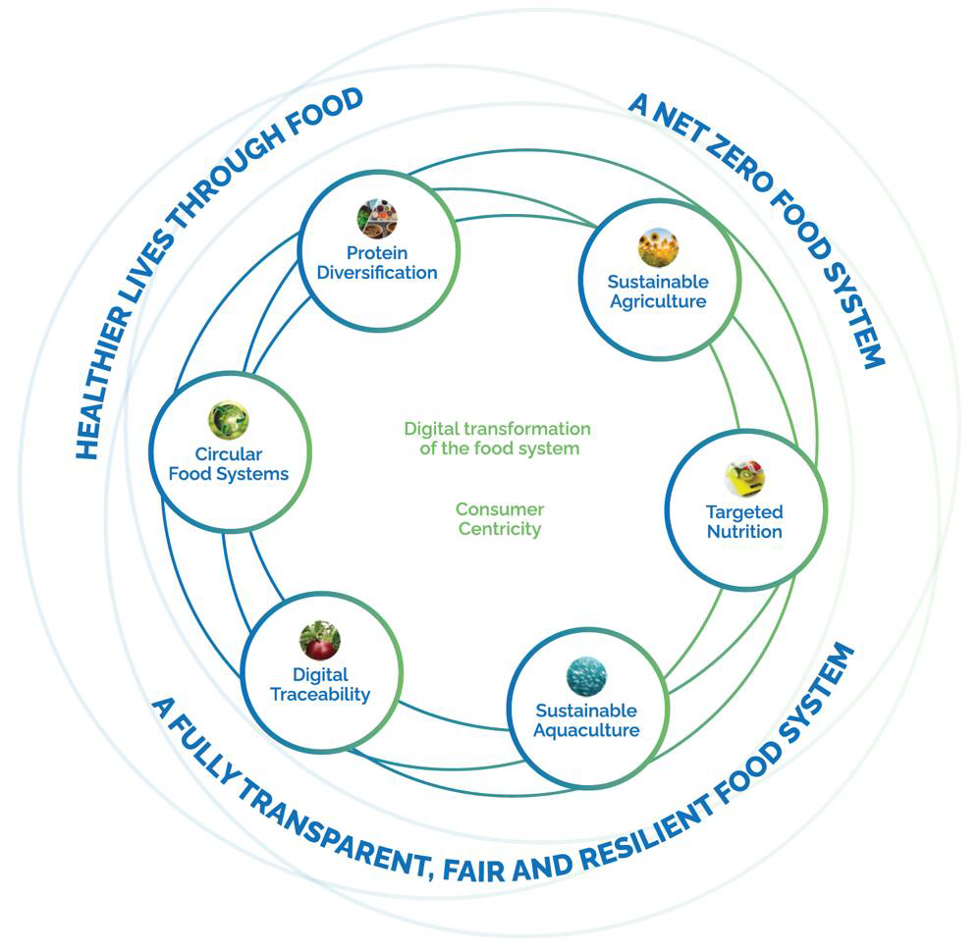

EIT Food CLC North-East, one of the EIT Food co-location centres (CLC), is based in Warsaw covering a vast region of Central and Eastern Europe (CEE), as well as the Nordic countries. EIT Food CLC NE is also one of the two CLCs implementing EIT Regional Innovation Scheme (RIS) instruments, supporting those regions in Europe which particularly require support for innovation in the agrifood sector.
EIT RIS activities seek to improve knowledge triangle integration and the innovation capacity of local ecosystems in the countries and regions with modest and moderate innovation performance.

EIT Food has defined a Competency Framework of eight priority areas to develop talent in the food system:
1) Entrepreneurship. The ability to recognise, develop and act on entrepreneurial opportunities in a range of organisation settings, and to play an effective role in new venture formation and growth.
2) Problem-solving. The ability to analyse and understand the problem space, generate new ideas, assess their validity, and co-create solutions.
3) Critical thinking. The ability to assess facts and evidence to drive decision-making, including constructive questioning of the status quo.
4) Leadership. The ability to be an effective leader, and to mobilise resources efficiently to accomplish a goal based on responsible management practice.
5) Communication. The ability to drive interpersonal communication and translate complex ideas for different audiences.
6) Technology management. The ability to use emerging technologies in (radical or breakthrough) innovation processes.
7) Data management. The ability to develop and use digital tools with the purpose of accessing, managing, analysing and interpreting data.
8) Food systems. The ability to analyse the food system, appraise current and future sustainability challenges, and develop appropriate responses using system approaches.
EIT Food’s educational activities, workshops and training for students, startups and other stakeholders shall support the development of at least two priority areas.
Figure 1. Competency framework
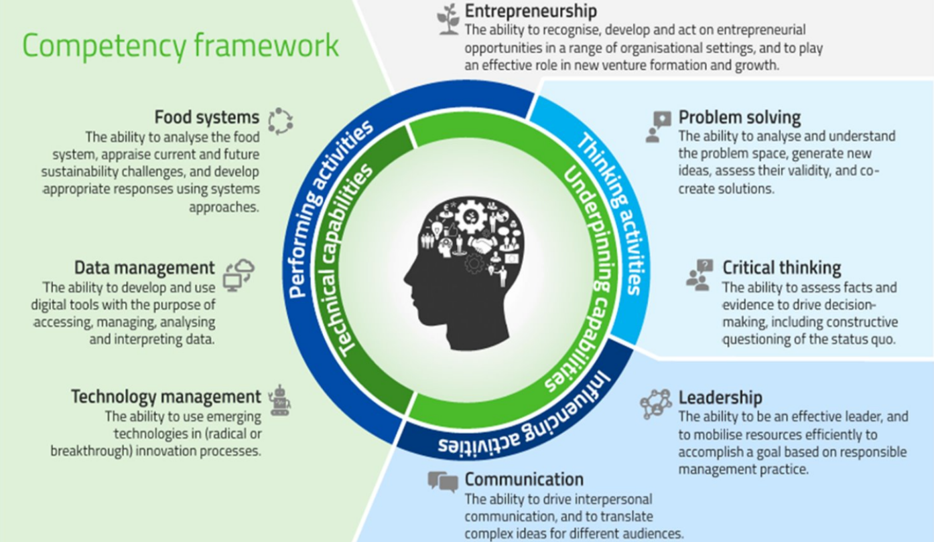

Background information: EIT Food Startup Awareness Event
The present call is launched by EIT Food to select organisations that would become organisers of the Startup Awareness Events. Each organiser will organise one event in their country (the ”Event”).
The main goal of the Event will be to introduce EIT Food programs and activities to the local agrifood and innovation ecosystem and scout for potential participants of EIT Food entrepreneurship programs. The Event will also aim to bring together the members of the local agrifood ecosystem and initiate the discussion about the current state and challenges of the ecosystem in relation to innovation and entrepreneurship.
The selection process is implemented as an open call managed by EIT Food Co-Location Centre North-East using clear and transparent selection criteria.

  - Event format and requirements
The proposed format of the Event should consist of 2 parts:
- A training program for entrepreneurial talents and/or early-stage agrifood startups. The organizer will scout innovative agrifood companies and invite them for a piece of training on a chosen topic (e.g. business modelling, sales, pitching, marketing, customer discovery, global agrifood trends, local support opportunities, etc.) run by invited local and foreign speakers (min. 6 hours). The workshop for entrepreneurial talents and/or early-stage agrifood startups shall refer to EIT Food Competency Framework and help to develop at least two of eight priority areas (please see Figure 1) ;
- A networking event for the members of the local agrifood and innovation ecosystem (startups, investors, food companies, universities and research centres, Ministries, Innovation Agencies, companies from the agri-food sector, clusters, farmer associations, etc.). The event will serve as a platform to discuss the current challenges in the local food system and present the EIT Food activities to the invited audience (min. 3 hours/180 minutes) and include Introduction to EIT Food and its activities prepared in collaboration with EIT Food’s representatives.
Both parts of the Event should be organised between October 2023 and 1st February 2024
The chosen organiser should also be able to conduct both parts of the Event online, in case it is impossible to organise the Event in a physical format. The details on formats and timeline are going to be decided based on proposals from applicant organisations.
The applicants are welcome to introduce more detailed information to the proposed format of the Event to better realise the purpose of the Event in the target countries. The selected organisations will work closely with EIT Food on customising the format and schedule of the Event to the peculiarities of the local agrifood and startup ecosystem.

Event budget
The selected organisations will sign a subcontracting agreement with EIT Food’s Co-Location Centre North-East with gross funding of up to 10,000€ (per the Event) to cover the eligible costs of the Startup Awareness Event.
When applying for the call, interested organisations should submit an agenda proposal aligned with the Event format requirements and a short budget proposal listing the costs associated with the Event planning and organisation.

Applications to organise the EIT Food Startup Awareness Event
EIT Food invites organisations from Countries or regions listed in point 3.1.to submit their proposals to become an organiser of the EIT Food Startup Awareness Event.

Countries or regions targeted by the call
Each application should concern one of the following countries:
- Montenegro,
- Outermost Regions: Guadeloupe, French Guiana, Réunion, Martinique, Mayotte and Saint-Martin (France), the Azores and Madeira (Portugal), and the Canary Islands (Spain).

Each applicant can prepare only one application (for one country).

Eligible organisations
- Legal persons (such as companies, incubators or accelerators, innovation centres, higher education institutes, research institutes, non-governmental organisations),
- Operating in a country/region targeted by the call,
- Able to sign a subcontracting agreement with EIT Food’s Co-Location Centre North-East and act as a subcontractor in a project funded based on Horizon Europe/EIT modalities,
- Recognised as important players in the local innovation ecosystems with a strong regional outreach,
- Experienced in entrepreneurship support,
- Capable of organising local events and workshops,
- Experienced in the organisation of events/workshops remotely using online tools,
- Able to organise the EIT Food Startup Awareness Event in the respected timeframe between October 2023 and 1st February 2024.

Benefits for organisations selected as EIT Food Startup Awareness Event organisers
Organisations chosen by EIT Food to organise the Event will be offered the following benefits:

- Ability to benefit from the association with EIT Food and the EIT community (as subcontractors in EIT Food activities);
- Subcontracting agreement with EIT Food’s Co-Location Centre North-East with gross funding of up to 10,000€ (per the “Event”) to cover the eligible costs of the EIT Food Startup Awareness Event’s planning and organisation;
- Expertise and organisational support of EIT Food and Co-Location Centre North-East in organising and implementing the Event.

Organising the EIT Food Startup Awareness Event shall be considered an opportunity to become associated with EIT Food, establish relations with its community and become better embedded in the EIT Food activities. The selected organisation will also benefit from the increased visibility in their local innovation ecosystems, strengthening their position on the regional and national levels.

Selection process

Interested and eligible organisations are invited to submit their applications in English by 23:59 CEST on 15 September 2023 using the “EIT Food Startup Awareness Event – Application Form”. Please send the electronic version of the application, based on the form provided below, to: ris@eitfood.eu with the title “Call for expression of interest to organise the EIT Food Startup Awareness Event”.
Incomplete applications or applications submitted by ineligible organisations will be automatically rejected. Complete applications received by EIT Food will be evaluated by a committee including representatives of EIT Food using selection criteria presented in point 3.5.
EIT Food reserves the right to designate the subcontractors only if the submitted applications ensure the excellence and value for money, and to relaunch the call if the present selection process would not yield satisfactory results. EIT Food reserves the right to contact the applicant organisations by e-mail or phone asking for additional explanations or supporting documents, and to schedule selection interviews with short-listed organisations. All applications will be evaluated using transparent selection criteria and the results of the call will be published by EIT Food on its website. The selected organisations will be required to sign subcontracting agreements with EIT Food’s Co-Location Centre North-East (Warsaw). If for some reasons on the part of chosen organization the subcontracting agreement is not signed in a month after the announcement of the call results, EIT Food may select another applicant based on the ranking lists without launching additional call.

Selection criteria
All proposals will be evaluated taking into account the following criteria, related to the applicant organisational capacity and EIT Food Startup Awareness Event requirements:
- Experience in training and supporting innovative startups (examples of the most relevant workshops/trainings from 2017-2022 that were provided by applicant organisation to entrepreneurs and startups from the region, including short description of these activities, key outcomes and impact);
- Experience in organisation of events in the field of agrifood concerning innovation/entrepreneurship/foodtech/policy or consumer dialogue (examples of the most relevant events/projects in the field of agrifood that were organized by applicant organisation in 2017-2022 including short description of these activities, type of an engagement in the project, project partners, key outcome, etc.);
- Role in the ecosystem (familiarity with the agrifood industry in the target country; existing contacts and projects with relevant local stakeholders; existing pipeline of early stage innovative startups);
- Approach to the organization of EIT Food Startup Awareness Event (proposed Event format (offline and online), specific topics, speakers and how they correspond to the purpose of the Event outlined by EIT Food;
- Cost of service planned by applicant organisation.

Criteria 1-4 will be evaluated on a 0-15 scale: 0 – not satisfactory; 5 – satisfactory; 10 – good and 15 points – very good. The application can receive max. 60 points for criteria 1-4.
In criterion 5 application with the lowest price will receive 40 points while other applications will receive proportionally lower numbers.

EIT Food Startup Awareness Event – Application Form

Please fill in the application form, ensuring that all fields are completed. Please submit the application in electronic format both as PDF and editable MS Word files by 23:59 CEST on 15 September 2023 to: ris@eitfood.eu. Applications incomplete or sent after the deadline will be rejected. Please do not provide further supporting documents and capture all relevant information in this form.
1. What country/region are you applying from (underline one)?
- Montenegro
- Outermost Regions: Guadeloupe, French Guiana, Réunion, Martinique, Mayotte and Saint-Martin (France).
2. Name of the applicant organisation in English
3. Name of the applicant organisation in local language
4. Legal form
5. Office address (street, city, country)
6. Website address
7. Type of organisation (underline one)
business enterprise | higher education institute | public research organisation
knowledge transfer intermediary (incl. industry association, innovation cluster, technology park, entrepreneurship support organisation)
other (please specify)
8. Name of contact person
9. Position
10. E-mail
11. Phone
12. Year of establishment of your organisation
13. Total number of employees
14. Please list social media channels currently used by your organisation (with web addresses):
Facebook
Twitter
LinkedIn
YouTube
Other (please specify)
15. Please provide a brief description of your organisation and its main activities:
16. Please provide examples of the most relevant workshops/trainings from 2017-2022 that were provided by your organisation to startups from your region, including short description of these activities, key outcomes and impact [Experience in training and supporting innovative startups:
17. Please provide examples of the most relevant events/projects in the field of agrifood that were organized by your organisation in 2017-2022 including short description of these activities, type of your engagement in the project, project partners and key outcomes [Experience in the organization of events in the field of agrifood dedicated to innovation/entrepreneurship/foodtech]:
18. Please present familiarity with the agrifood industry in the target country; existing contacts and projects with relevant local stakeholders; existing pipeline of early stage innovative startups [Role in the ecosystem]:
19. Please propose the agenda of two parts of the Event (startup training and networking event), including the subjects and preliminary speakers (please take into account the guidelines provided by EIT Food on page 2) [Approach to the organization of EIT Food Startup Awareness Event]:
20. Please describe the tools and format you would use if you had to organise both parts of the Event online [Approach to the organization of EIT Food Startup Awareness Event]:
20. Please propose the Event budget (in EUR), taking into account the guidelines provided by EIT Food (page 2) [Cost of service planned by applicant]:
21. Would you like to add any other information relevant to this call and application?

By submitting this application form, I confirm that the information provided above correctly represents the scope of activities and plans of my organisation. I understand that the information provided in this form may be used to define obligations and performance targets in subcontracting agreement. I give consent to processing the application by EIT Food, its Co-Location Centres and external experts involved in the evaluation process. I am willing to cooperate and provide further information or documents confirming the facts presented above. If selected by EIT Food, I declare the willingness to act as the organiser of the EIT Food Startup Awareness Event in 2023, based on conditions described in the “Call for expression of interest to organise the EIT Food Startup Awareness Event”.

Date, place ……………………………………………………………………
Name of the person submitting the application ……………………………………………………………………
Position ……………………………………………………………………
Organisation submitting the application ……………………………………………………………………

Consortia are not eligible in this call.

