

Call for Expression of Interest

EIT Food Evaluators in Agriculture

Annex 3: Application via MyEITFood portal

The applicants are requested to submit their application via our MyEITFood portal, here.
If you have used the platform before, you can login using your already existing credentials. If you are new to the platform, click “Register here” and continue to fill the fields as requested. Once registered, you will receive an email confirmation. Click on the link in the email to set your password.
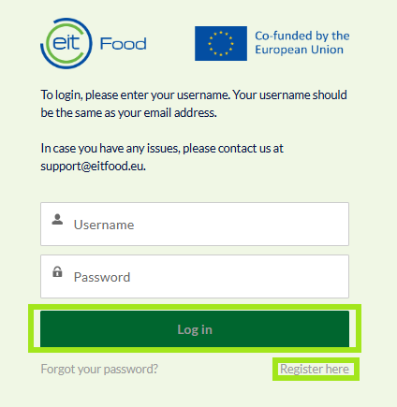

Once you login you will be directed to the EIT Food application portal where you can create and work on your application.
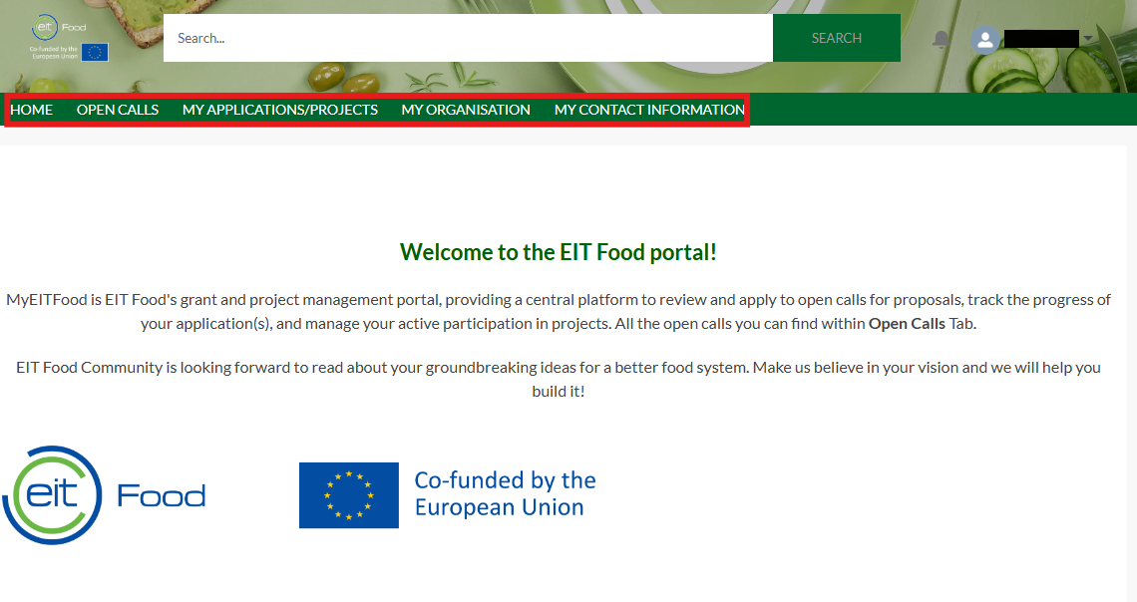

Please take note of the five tabs aligned on the dashboard.
To find the Call for Agriculture Evaluators 2026 and begin your application process, click on “Open Calls” in the dashboard. Here you will see all open calls.
To select the correct call, click on “C Call for Agriculture Evaluators 2026” .
To proceed with your application, click the “Create application” button in the top right corner.
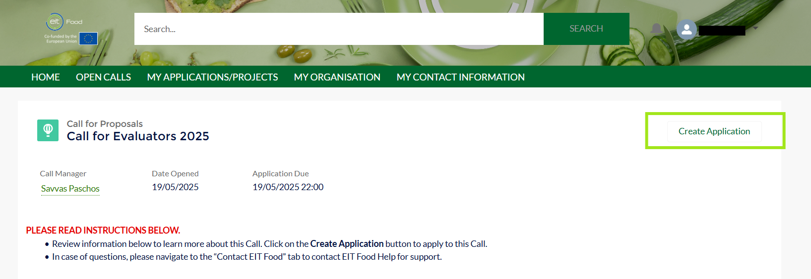
To create your application, you will be asked to provide the name of your application which should have the format “Name Surname”. Following this you will reach the first steps of the application.
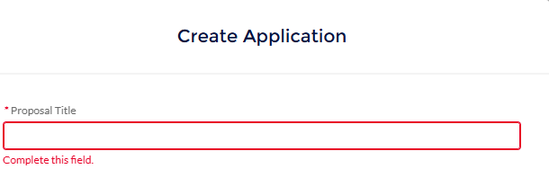
You will also be required to add a Description in the Details tab of the application form. Please add: Evaluator Application – Name + Surname.

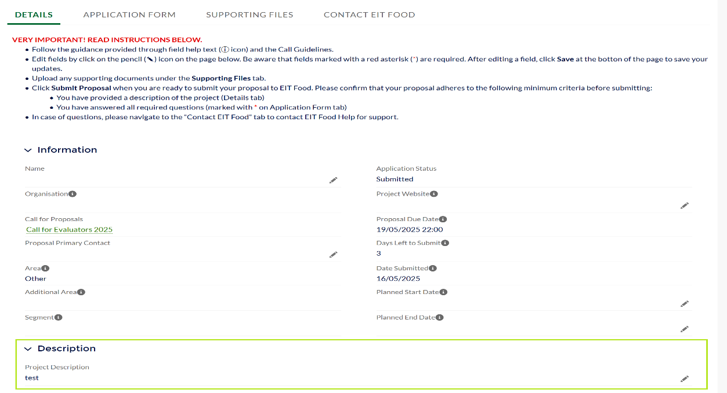
To start including information for your application you need to navigate to the tab “APPLICATION FORM”. Please ensure that you respond to all questions with the most accurate, complete, and up-to-date information.
To add your CV, click on the “Supporting Files” tab and click on the Upload Files. To adjust the files, click on the drop-down box.
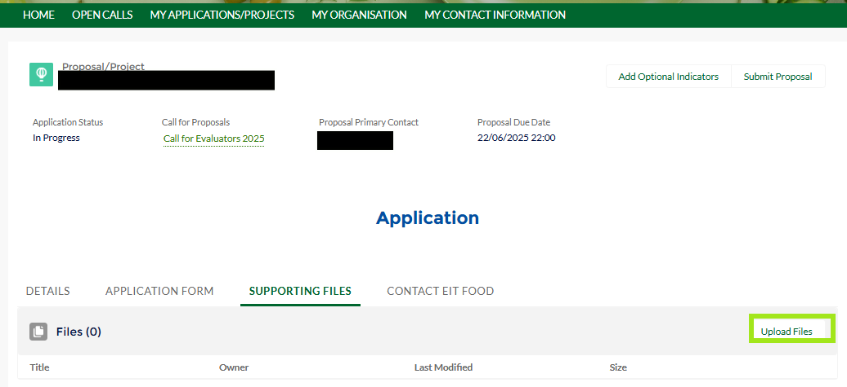
When you have completed all fields according to the call guidelines and uploaded the necessary files to support your application, you can submit using the “Submit Proposal” button.
